Name: ________________________________________________________ Period: _________ Date: ______________
Photosynthesis MCAS Questions
- Researchers studied a typical hardwood forest containing a variety of trees, other plant species, fungi, and animals. The atmospheric carbon dioxide concentrations around the forest were measured in the middle of the day. The carbon dioxide concentration was lowest right next to the forest and steadily increased as the researchers measured farther away from the forest.
- Identify and describe one biological process that raises carbon dioxide concentrations by adding carbon dioxide to the atmosphere.

- Explain why the lowest carbon dioxide concentration occurs closest to the forest. Be sure to include a biological process in your answer.

- Describe how nighttime carbon dioxide concentrations near the forest should compare with the midday concentrations near the forest. Explain your answer using two biological processes.

- Mallory has four aquatic plants of the same size and species. She submerges each plant in a separate beaker filled with 200 mL of water. She then sets each beaker under a different intensity of light. Mallory observes that, of the four plants, the plant in the beaker under the most intense light gives off the most gas bubbles in a 20 min period.
Which of the following statements best explains Mallory’s observations?
 | A. | Cells decompose most quickly under the most intense light.
 | B. | Water evaporates from plants fastest under the most intense light.
 | C. | Photosynthesis occurs at the highest rate under the most intense light.
 | D. | Gases in the leaves of plants expand most under the most intense light.

- Which of the following occurs during photosynthesis?
 | A. | CO₂ is used to produce water.
 | B. | CO₂ is absorbed by mitochondria.
 | C. | CO₂ and H₂O are converted to carbohydrates.
 | D. | CO₂ and H₂O are combined into carbonic acid.

Name: _______________________________________________________ Period: _________ Date: ________________
Cell Respiration MCAS Questions
- Plants absorb solar energy during photosynthesis. The graph below represents how this energy is distributed in some plants.

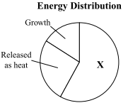

Which of the following statements describes what happens to the energy represented by the section labeled X?
 | A. | It is recycled to the Sun.
 | B. | It is consumed by decomposers.
 | C. | It is lost to the soil and the atmosphere.
 | D. | It is used for cellular respiration and maintenance.

- All organisms have ways to produce ATP. Which of the following statements describes why ATP is a critical compound for all cells?
 | A. | It causes mitosis to begin.
 | B. | It is an energy-transfer molecule.
 | C. | It is a major component of cell membranes.
 | D. | It carries information from DNA to the ribosomes.

- Which of the following most likely happens in the cells of a person running in the Boston Marathon?
 | A. | The respiration rate increases to produce more ATP.
 | B. | The replication rate increases to produce more DNA.
 | C. | The photosynthesis rate increases to produce more sugars.
 | D. | The cell division rate increases to produce more muscle fibers.

- In which of the following ways are photosynthesis and cellular respiration alike?
 | A. | Both processes produce glucose.
 | B. | Both processes consume carbon dioxide.
 | C. | Both processes take place in chloroplasts.
 | D. | Both processes involve energy transformations.

- The graph below shows the amount of ATP produced in a cell during a period of time.
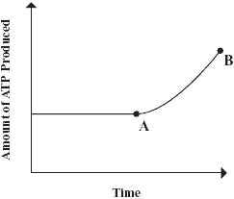
According to the graph, which of the following processes must have increased between points A and B?
 | A. | cellular respiration
 | B. | cytokinesis
 | C. | DNA replication
 | D. | meiosis

- Which of the following statements describes the role of ATP in animal cells?
 | A. | ATP stores and releases energy.
 | B. | ATP forms the channels in the plasma membrane.
 | C. | ATP serves as the hereditary material in the nucleus.
 | D. | ATP attaches to and digests unneeded organic molecules

- Energy for most chemical reactions in cells is supplied by which of the following molecules?
 | A. | ATP
 | B. | DNA
 | C. | adrenaline
 | D. | hemoglobin

- Milk is an important part of many people’s diets. When the word milk is mentioned, most people think
of dairy milk derived from cows. Many people, however, cannot drink dairy milk because of lactose
intolerance. Individuals with this condition are unable to digest a component in the milk called lactose.
Lactose is the sugar in dairy milk. It is a disaccharide made from the sugars glucose and galactose.
Lactose-intolerant individuals lack the enzyme lactase, which is needed for the digestion of lactose sugar.
Many lactose-intolerant individuals drink soymilk instead of dairy milk. Soymilk is produced from
soybeans (the seeds of the soybean plant) and is a nutritious substitute for dairy milk. Soymilk contains
protein, calcium, and other essential nutrients just as dairy milk does.
The table below compares some of the nutrition information for a serving of dairy milk and a serving
of soymilk.
Dairy Milk and Soymilk Nutrition Information
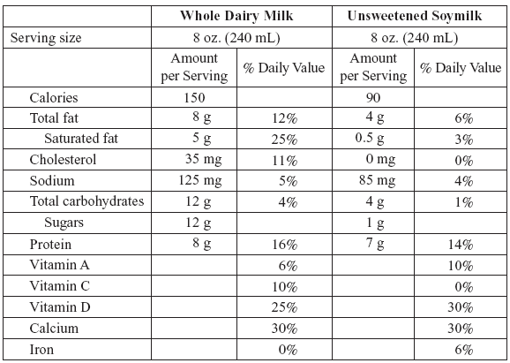

Which type of milk, per serving, will theoretically yield a greater amount of ATP in the human body, and what is the reason for this?
 | A. | dairy milk, because it contains vitamin C
 | B. | soymilk, because it contains no cholesterol
 | C. | dairy milk, because it has larger amounts of sugar and fat
 | D. | soymilk, because it has larger amounts of vitamins A and D

- The following section focuses on the interactions of organisms in a food web.
A partial food web for organisms in Yellowstone National Park is shown below.

Which process do the animals in the food web use to convert energy from food into ATP?
 | A. | cellular respiration
 | B. | osmosis
 | C. | photosynthesis
 | D. | transcription

